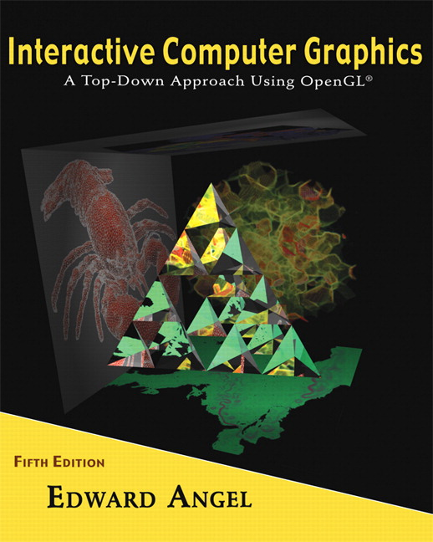 COSC 4370
Name: ____________________ TERMINAL # ____
Programming Assignment 4 Acceptance Testing:

After you downloaded your zipped project from BB and rebuilt it using the 200 PGH Visual Studio 2010, take screenshots of the output produced, and insert it in this file ……..
Particle Systems:
1. Replace sphere and cubes with particle systems sphere and cube, texture map them (happy faces??).
SCREENSHOT Output of your program is:
……..

Particle System:
2. Add the fountain.cpp particle system fountain in the middle of your pond.
SCREENSHOT Output of your program is:
……..

5. Navigating:
1. Have duck swim around the fountain in the pond.
SCREENSHOT Output of your program is:
……..

Navigation:
2. Have dinosaurs walk towards your sphere and cubes with the intent to collide with them. When you collide you can simulate any desired effects like explosion, etc. Successful collision with the 2 objects will mark the completion of your summer project.
SCREENSHOT Output of your program is:
……..

Navigation:
3. If you have dinosaurs collide with the electric fence surrounding the JURASIC PARK and create a spark and a roar you will get extra credit. (20 points)
SCREENSHOT Output of your program is:
……..

Source Code:
1. Copy and Paste your .c (.cpp) file here:
…….

When done attach this file to “Testing Programming Assignment 4” BB assignment.

